
Pageant Day: Contact Information:
Saturday, November 14th, 2026 @ 3:00 PM MissNiles.org
Doors open at 2:30 PM MissMrNilesCourts@gmail.com

Rehearsals Schedule
Rehearsals are held on Sundays: *9/27, *10/4, 10/11, 10/18, 10/25 & 11/8
- *9/27 and 10/4 are for Miss, Mr. and Teen contestants ONLY
- Miss/Mr & Teens: 11am-1pm
- Little Miss/Mr & Jr. Teens: 1:30pm-3pm
- Please bring your $50 registration fee to the first rehearsal, if you did not pay at the kick-off meeting.

Arrival Expectation
Contestants are encouraged to arrive at rehearsal ready to go 10 minutes before the scheduled start time. Rehearsals are closed to parents. After check-in, parents should leave and return 10 minutes before the end of rehearsal for a brief wrap-up meeting.

Dress Rehearsal
- Friday, November 13th — Niles High School PAC — 4:00 pm - 8:00pm
Pageant Day
- Saturday, November 14th —Niles High School PAC — Check-in begins at 10:30am
Contestant Expectations:
Practice Attire & What to Bring:
- Wear casual attire that allows you to dance and move comfortably.
  - Please keep midriff covered. Bottoms to be at least finger tip length.
- Bring your pageant shoes to practice walks.
- Bring a water bottle. Miss, Mr. and Teens may want to bring a snack.
- Bring a positive attitude, a willingness to learn, and your smile!
Zero-Tolerance Rules:
- Social Media - Contestants who have social media accounts MUST turn in all account handles and allow Chairmen to follow those accounts.
- Solo Cup Rule - No photos may be taken with Solo cups of any kind. This is also a Blossomtime rule. Failure to follow this policy will result in a meeting with the Chairpeople and the Blossomtime office. The organization maintains a zero-tolerance policy regarding underage drinking.
Opening Dance Routine:
- Contestants will learn the opening dance during rehearsals. Video instruction will be shared through the BAND app. Because rehearsal time is limited, contestants and parents are responsible for making sure contestants are practicing at home. We notice the contestants who put in the extra work.
- Miss & Mr. - Costumes will be provided. Miss contestants will need to supply Black Ballet Flats and Black Opaque Tights. Mr. contestants will need to wear black or grey sneakers.
- Little Miss/Mr., Jr. Teen & Teen - Pageant T-shirts are required for all contestants and will be provided by the MMNSO. These will be worn with black leggings, yoga pants, or black jeans with black/grey sneakers supplied by the family.
Interviews:
- Miss, Mr., Teens & Jr. Teens - Interviews will be held the day of the pageant with a panel of three judges.
  - Miss & Mr. contestants will also have a judges luncheon on pageant day.
- Little Miss/Mr. - Contestants will have individual interviews with a panel of three judges but will be interviewed by the judges one-on-one. It's less scary for them to sit with one person instead of three people.

Fundraising & Awards
**Ticket Sales - REQUIRED
- Every contestant is required to sell a minimum of 15 pageant tickets at $15 each.
  - Children age 5 and under are free.
  - Tickets are $20 at the door on pageant day.
  - Seating is first come, first served. There is not a bad seat in the PAC.
  - Reserved seating will be provided for judges and tellers.
- TICKET SALES AWARD
  - The contestant who sells the most pageant tickets will receive the ONLY reserved seating at the pageant. All other seating is general admission.
**Good Luck Ads (GLA) & Sponsorships - REQUIRED
- Every Contestant must sell at least $250 in GLA/Sponsorship sales.
- ENTREPRENEUR AWARD
  - The contestant with the highest GLA/Sponsorship sales will receive the Entrepreneur crown and banner, plus 10% of their total sales returned in the form of a Visa gift card.
**People’s Choice (Can Fundraiser) - REQUIRED
- Each contestant must decorate a can of their choice, such as a pringles or coffee container.
- Decorated cans will be displayed on pageant day.
- Contestants may place their decorated can at a local business to collect additional donations and votes.
- Every $1 donated = 1 vote
- The winner will receive a $50 gift card to 2nd & Main in Niles.
Miss & Mr. Niles Recruitment
- All Miss, Mr., Teen, Jr. Teen, and Little Miss/Mr. Contestants are eligible to participate in the recruitment Prize for bringing in Miss and Mr. Niles contestants. One winner will be selected at random on pageant day and receive a $100 gift card.
  - 1 contestant recruited = 1 entry
  - 2 contestants recruited = 3 entries
The More the Merrier Challenge
- If at least 10 Miss Niles contestants and at least 4 Mr. Niles contestants compete on pageant day, those Miss and Mr. contestants who have met both the minimum ticket-sale requirement and the minimum GLA/Sponsorship requirement will receive a $100 scholarship.

September 27th - First Rehearsal @ Niles YMCA
MISS/MR & TEEN Practice ONLY
- Enrollment Forms DUE for MISS/MR/TEEN contestants
  - Application
  - Proof of Residency
  - Proof of GPA (Miss and Mr. Only)
  - Medical Release
  - Photo Release
  - Social Media Release
  - Certificate of Understanding
  - Entry Fee ($50.00) per contestant if not paid at the kickoff meeting
- Practice Itinerary
  - Meet and Greet
  - Assign Contestant Numbers
  - Reveal Commercial theme
  - Teach First Formal Walk
  - Discuss Interview workshop, clothing attire, and opening dance
- Jr Teen/Littles
  - NO REHEARSAL THIS WEEK

October 4th - Second Rehearsal @ Niles YMCA
MISS/MR & TEEN Practice ONLY
- Miss/Mr./Teen- Last Day To Register!!
- Enrollment Forms are DUE for ALL contestants
  - Application
  - Proof of Residency
  - Proof of GPA (Miss and Mr. Only)
  - Medical Release
  - Photo Release
  - Social Media Release
  - Certificate of Understanding
  - Entry Fee ($50.00) per contestant if not paid at kickoff meeting
- Miss/Mr & Teens
  - Commercial topic DUE
  - Teach opening number/dance
  - Review first formal walk
- Jr. Teens & Littles
  - NO REHEARSAL THIS WEEK

October 11th - Interview Workshop @ Niles YMCA
- MISS/MR & TEEN
  - Interview workshop with Gail Freehling (Miss and Miss Teen contestants only)
    - Bio training, interview training (physical and non-verbal training included)
    - Miss & Teen contestants are to wear an interview dress and heels. Mr. contestants are to wear a suit and tie.
  - On-Stage Question Overview
  - Rough Draft of Bios Due - Need this for interview workshop!!
  - Dress Approval Sign Up Sheet for 10/25
- Jr. Teens & Littles - First Rehearsal & LAST DAY to register!!
  - Enrollment Forms are DUE
    - Application
    - Medical Release
    - Photo Release
    - Social Media Release
    - Certificate of Understanding
    - Entry Fee ($50.00) per contestant

  - Assign Contestant Numbers
  - Teach Opening Number/Dance
  - Teach Introduction & Formal Walk
  - Miss & Teen Homework: Makeup video by Miss Katelyn
October 18th - Fourth Practice @ Niles YMCA
- MISS/MR. &TEEN
  - Review First Formal Walk
  - Review Opening Number
  - COMMERCIAL REHEARSAL
  - HOMEWORK MISS & TEEN: Watch the makeup video from Miss Katelyn
- Littles/Jr. Teen
  - Review Opening Number/Dance
  - Review Introduction & Formal Walk
  - Rough Draft of Bios DUE

October 25th - Fifth Rehearsal @ Niles YMCA
Program Headshot day for ALL CONTESTANTS - wear something solid colored (avoid patterns)
- Items Due for EVERYONE:
  - Final Draft of Bios DUE
  - GLAs/Sponsorships DUE - No Exceptions
    - Ads are to be emailed or turned in via flash drive no later then 11:59pm 10/25.
  - Miss/Mr. sign up for 1:1 (Not Mandatory)
- Miss/Mr. & Teens
  - Makeup Overview - MISS & TEEN to Come With Interview Makeup Complete
  - Commercial Rehearsal
  - Onstage Question Practice
  - Review First Formal Walk & Teach Second Formal Walk
  - Review Opening Number
  - DRESS APPROVALS
- Jr Teens & Littles
  - Review Walks
  - Review Communication
  - Review Opening Number

November 1st - 1:1 workshop
- This is ONLY for MISS/MR Contestants
- This is OPTIONAL, NOT a MANDATORY rehearsal
- Contestants can sign up for a 1-hour session to meet with chairman/committee to go over any areas that may need work
  - Interview
  - Commercial
  - Formal walks
  - Onstage Question

November 8th - Final Rehearsal @ Niles High School PAC
- Items Due for EVERYONE:
  - Ticket Sales DUE
- Miss/Mr & Teens
  - Commercial - MUST BE MEMORIZED
  - Onstage Question Overview
  - Review Formal Walks
  - Review Opening Number
  - Practice Coronation
- Jr Teen & Littles
  - Review Dance
  - Review Walks
  - Review Communication
  - Practice Coronation

November 13th - Dress Rehearsal @ Niles High School PAC
- 4:00 PM - 8:00 PM
- Items Due for EVERYONE:
  - Can Fundraiser (Peoples Choice) DUE.
- Run Entire Pageant from Start to Finish
- What to bring:
  - Opening Number shoes
  - Formal Walk Shoes
  - Water & Snacks - We will provide pizza & Water

November 14th - PAGEANT DAY!
- MISS/MR. & TEEN CONTESTANTS need to arrive by 10:30 AM dressed and READY for interviews. LITTLES/JR. TEENS need to arrive at 11 AM
  - Miss/Mr/Teen - Interview dress/suit
  - Jr Teen/Littles - Jeans, t-shirt, and black tennis shoes
- ALL CONTESTANTS must have ALL pageant attire when dropped off. Parents WILL NOT be allowed backstage once you drop your child off or during pageant.
  - (DON'T FORGET TO LABEL EVERYTHING!!)
- Doors open for FIRST COME, FIRST SERVE SEATING at 2:30 PM
- Pageant begins at 3:00 PM

PAGEANT DAY ORDER OF EVENTS
BEFORE PAGEANT
Interviews
Lunch
Makeup Stage Checks (Miss & Teen)

PAGEANT BEGINS @ 3 PM
Opening Dance Number
Onstage Question (Miss & Mr.)
Communications/Commercials
Returning Court Dance (2026 Court)
1st Formal Presentation
INTERMISSION (10 Minutes)
2nd Formal Presentation
2025 Court Farewells
Coronation

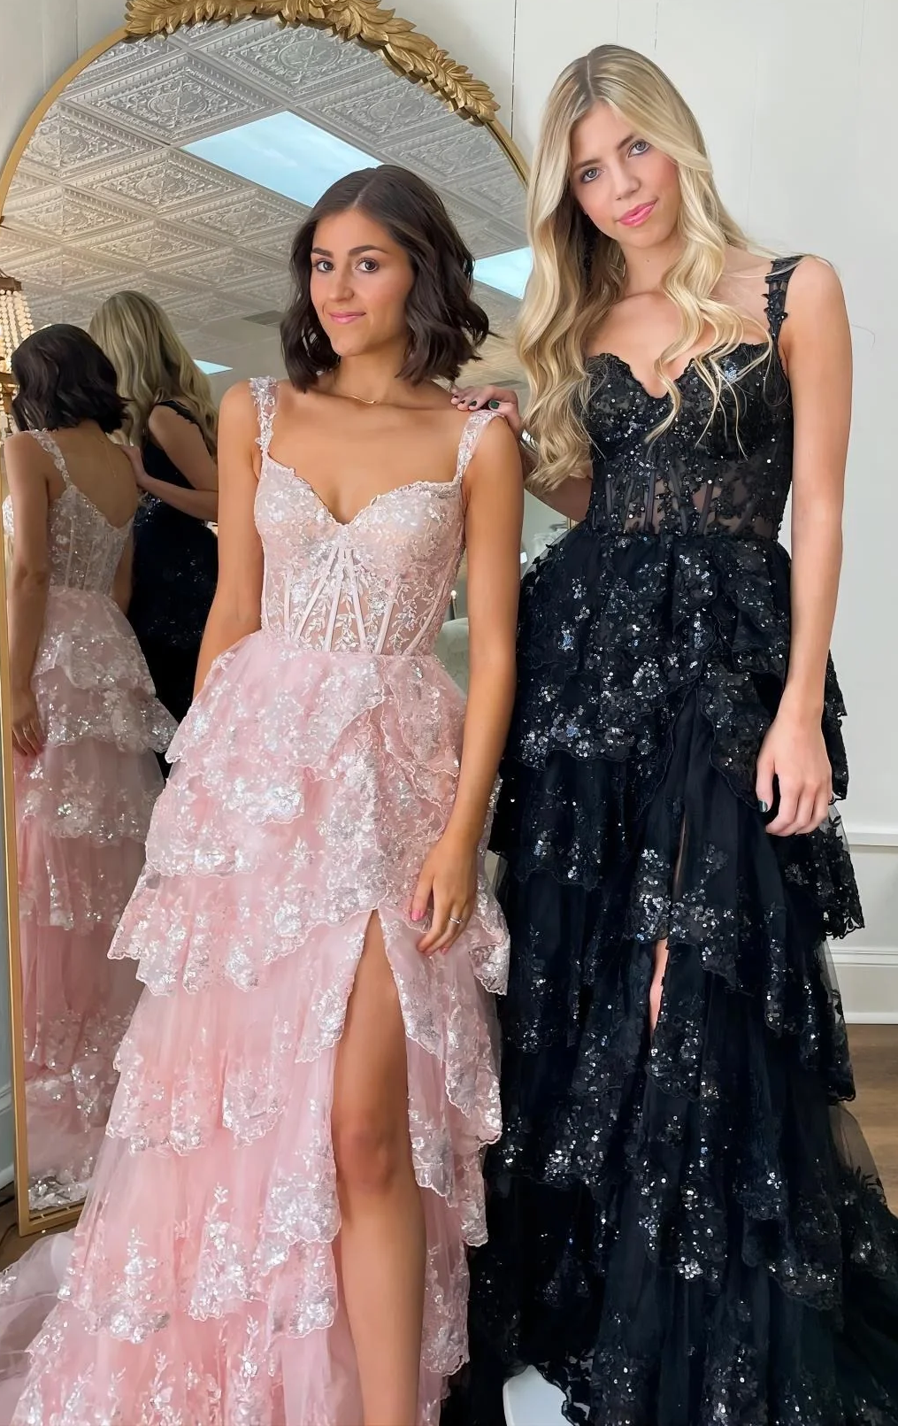
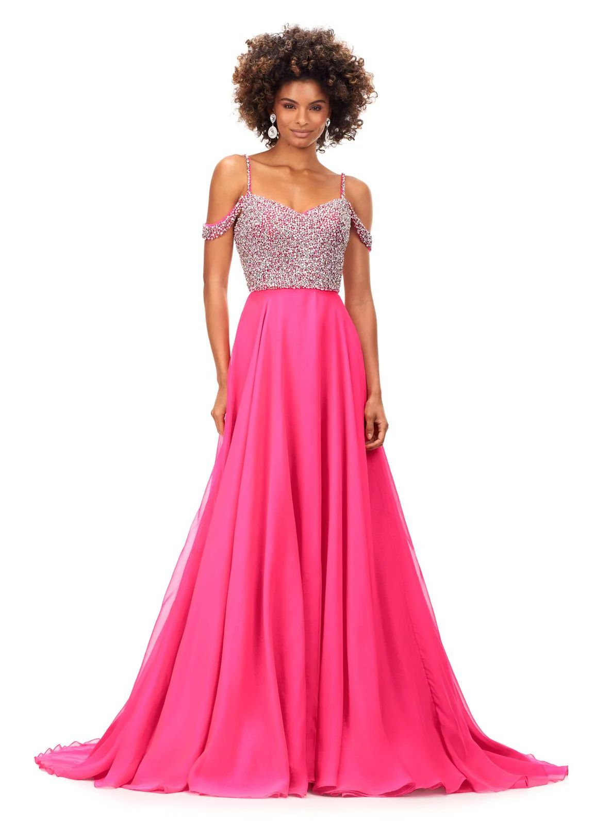

Miss and
Miss Teen
Approved Pageant Wear
● Slit 3 inches above knee
● Floor length gown
● NO open sides

● Heels at least 2 ½in
● Modest Neckline
● NO bare midriff
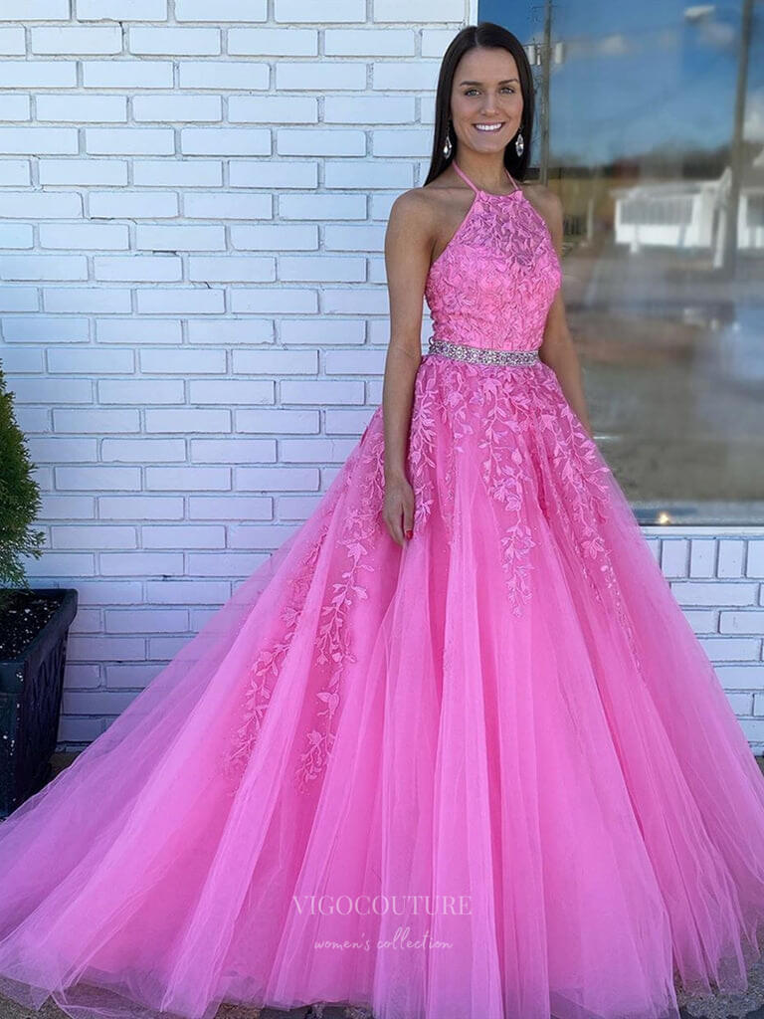
● NO plunging neckline

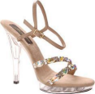

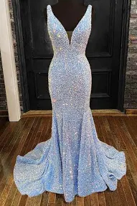


Miss and Miss Teen
Approved Interview Wear
● Dress is just above knee
● Close-toed nude pumps or colored heels that match accents of dress
● Heels/pumps at least 2 ½ inches
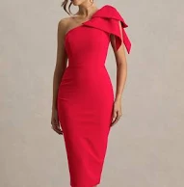
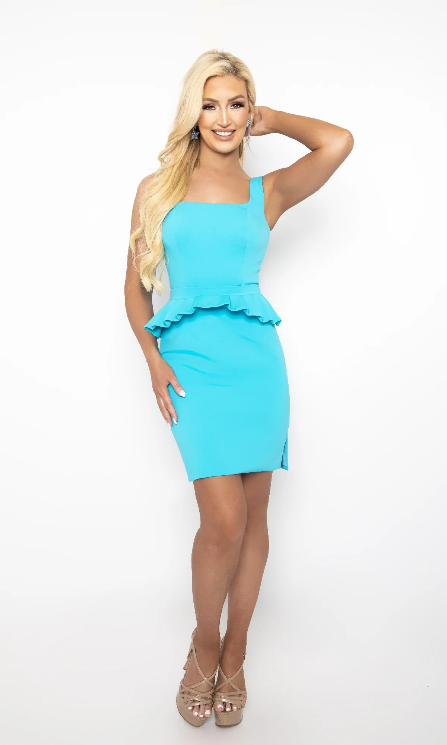
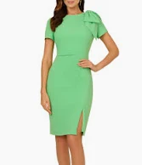
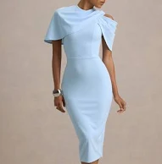
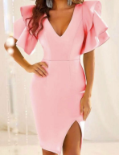
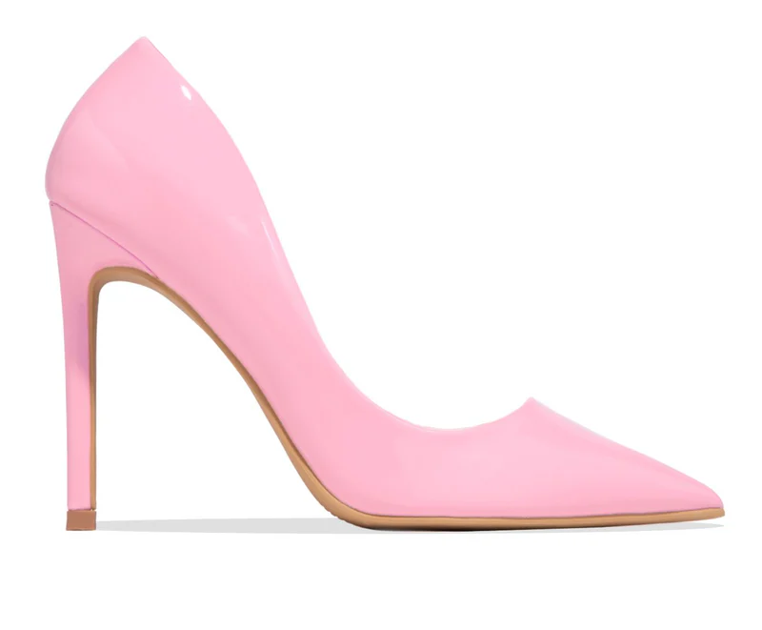
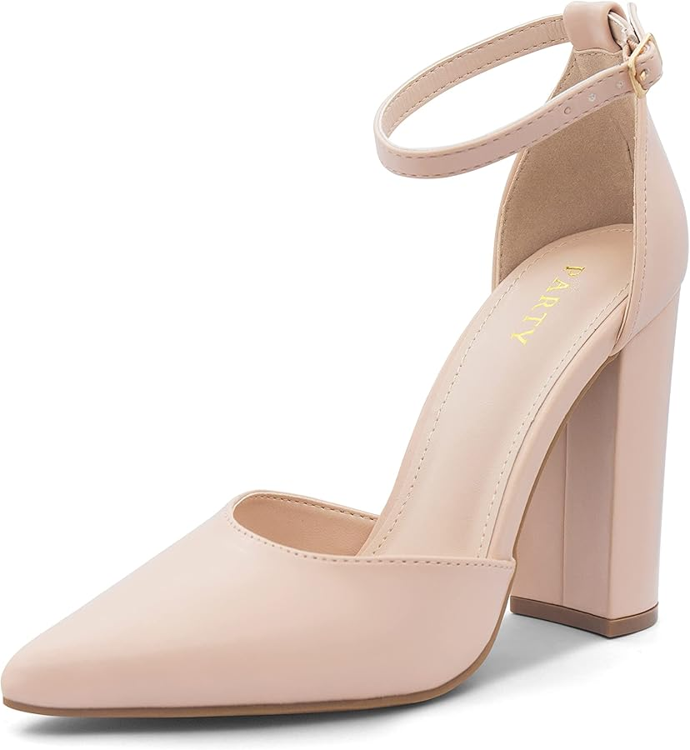
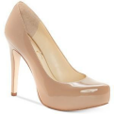

Princess and Jr Teen
Approved Pageant Wear
● Straps on dress
● Floor length or Tea length dress
● Nice flats or a heel, NO higher than 1 ½ inch
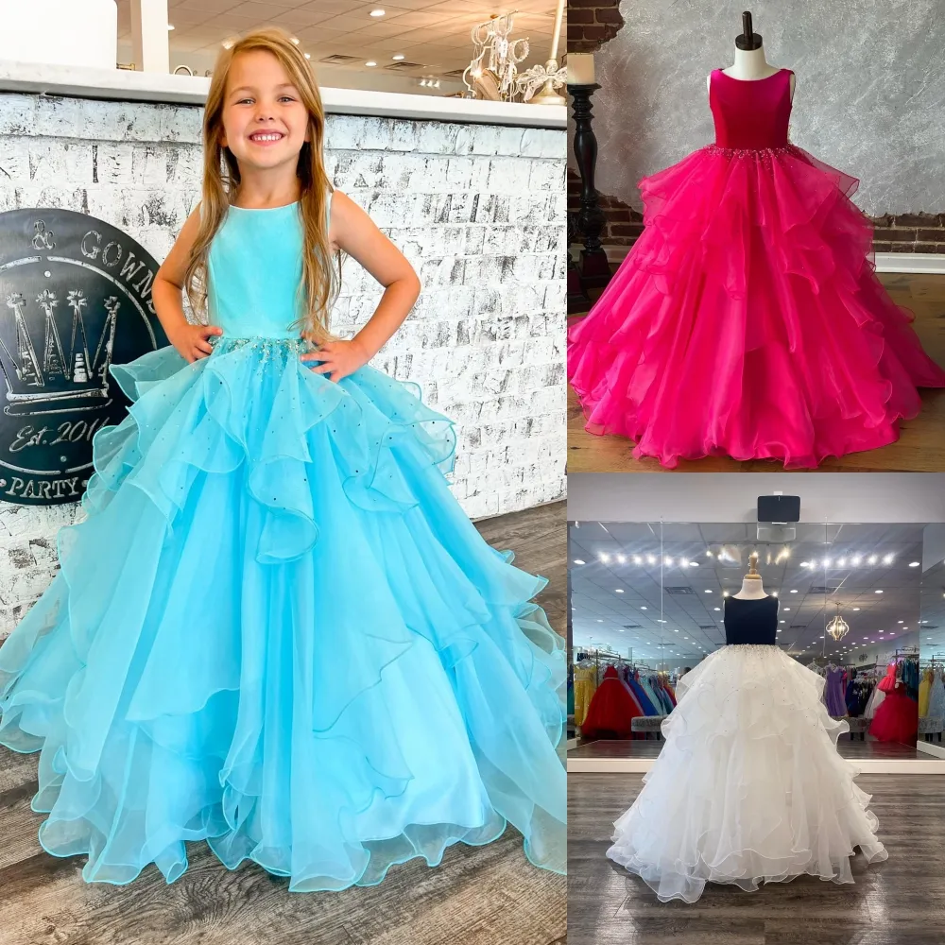
● NO open back

